考試

CPT 1

Computer System Structure

1. Hardware
2. Operating System (控制和協調Hardware 在Applications 和 Users 之間的使用)
3. Applications
4. Users

多個User 使用不同的Application , Operating System 分配 Hardware 提供 不同 Application 所需要的computing resource

Computer System Operation

- One or more CPUs

- device controllers

通過common bus 來提供鏈接去分享memory

Operating System Goal

- Execute User programs

- Make the computer system convenient to use

- Use Hardware resources in an effiecient manner

A program that acts as an intermediary between user/Application and hardware resource

OS

1. resource allocator

manage all resources

Decides between conflicting requests for efficient and fair resource use

1. Control program

Control execution of programs to prevent errors and improper use of the computer

Interrupts

- modern operating systems are interrupt driven. Events are almost always signaled by the occurrence of an interrupt or a trap.

- we need to make sure that an error in a user program could cause problems only for the one program running.

- A properly designed operating system must ensure that an incorresct program cannot cause other programs to execute incorrectly.

Storage Structure

Caches （速度快，但是容量小）

Main memory (CPU可以直接進行存取的最大storage)

Disk （CPU無法直接對其進行存取，必須先轉移到Main Memory）

HOW A MODERN COMPUTER WORKS

DEVICES >> CPU/GPU >> MEMORY 。 最後透過devices輸出

Single general-purpose processor

Multiprocessors（指擁有多個處理器）

Multicores （指一個處理器上有多個核心）

**Dual - Mode and Multimode Operations**

- In order to ensure the proper execution of the operation system, we must be able to distinguish between the execution of operating-system code and user-defined code.

- Two separate modes of operation : (user mode , kernal mode) . A bit , called the mode bit, is added to the hardware of the computer to indicate the current mode : kernel(0) or user(1).

- privileged instructions

- System calls provide the means for a user program to ask the operating system to perform tasks reserved for the operating system on the user program’s behalf. In all forms,it is the method used by a process to request action by the operating system.

Bookstrap System

在計算機開機時，負責初始化系統的各個部分，並加載操作系統内核以開始執行。

通常Bookstrap program會被放置在ROM 或EPROM，這些storage generally know as firmware，在啓動過程中是不可修改的，使她在開機時可靠地運行。

CHP2 System Structure

Chapter 3. Process concept

Chapter 4. Multithreaded programming

Chapter 5. Process scheduling

Chapter 6. Synchronization

Overhead - 只要computer system沒有在run user’s program的時候就叫Overhead

Chap 5

RR STF

作業系統組成的最重要的三個要素

- Process ，Memory ，Storage/File

PART 1 OVERVIEW

- System Structure

PART 2 Process Management

- processes concept

- multihreaded programming

- process scheduling

PART 3 Process Coordination

- Synchronization （最困難部分）

- Deadlocks

PART 4 Memory Manegement

- Memory-Management Strategies

- Virtual-Memory Management

PART 5 Storage Management

- File System

- Implementing File Systems

- Mass Storage Structure

- I/O Systems

筆記

Mainframe Systems （最早的電腦）

Computer-system architecture（各式各樣的電腦系統）

Special-purpose systems（特殊電腦-需要特殊考量）

**Mainframe Systems**

演變（從上往下）

Batch

Multi-programming (current)

Time-sharing(current)

Mainframes - 最早期的電腦，體積很大，非常昂貴，作用單一，每一臺的功能都不一樣

到先如今，專門處理某個一個問題的電腦，也稱作 Mainframes

**Mainframe : BATCH**

早期的電腦是讀卡片的，把程式寫在卡片上，再讓電腦去讀取。所以電腦的input就是一堆的卡片，然後每次只能處理一個程式，其他程式需要waiting，叫做BATCH。

Processing Steps:

1. User submit jobs后，會有一張LOAD的卡片，會把程式compile好后，再load到memory，再做執行，在把程式可能output到另一張卡片，然後END，再換下一張卡片。
2. 黨operator收到要執行的卡片后，需要自己根據要求sort jobs
3. OS 只是簡單的運行，並control from one job to next

缺點

one job at a time

No interaction between users and jobs, （它就只能切換job到下一個）

CPU is often idle（I/O speed << CPU speed） 因爲I/O很慢，那時候操作機器的是人。

OS doen’t need to make any decision , only 計算能力

**Mainframe : Multi-programming System**

爲了解決batch的缺點，可以讓系統run多個program, 可以重叠用I/O和program的時間，不會讓CPU idle.

（因爲早期的電腦需要CPU不斷地下指令和去檢測I/O的狀況才能完成一個I/O的動作）

系統要讓CPU和I/O可以多工，第一個先決條件：

1. Spooling *概念

CPU just needs to be notifiesd when I/O is done (希望在執行我們I/O的時候CPU能狗繼續做事情)

-Several jobs are kept in main memory at the same time, and CPU is multiplexed among them

（main memory可以儲存多個jobs在同一時間，CPU可以多工使用他們）

因此又一個問題產生了，因爲一開始的job都是存在Disk裏面，所以我要load哪一些job到我的main memory。然後又要從這麽多main memory 裏面挑哪些job到我的CPU上執行。因爲CPU的數量是有限的（<main memory）

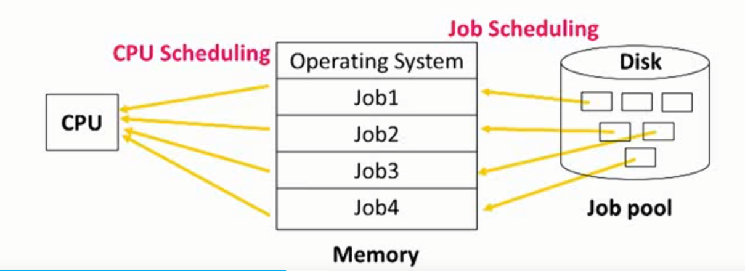

OS tasks

- memory management - the system must allocate the memory to several jobs（Job Scheduling）

- CPU scheduling - the system must choose among several jobs ready to run（多工執行）

- I/O system - I/O routine supplied by the sytstem,allocation of devices（不需要CPU命令）

**Mainframe :Time-sharing System(Multi-tasking System)**

通過multiproccessor解決了可以多工使用program，增加了電腦的效率，但是還沒有出現interactive between I/O and CPU ,而且還想要可以同時Multiple users 使用CPU 且互相不影響

- An interactive system provides direct communication between the users and the system

》CPU switches among jobs so frequently that users may interact with programs

》 CPU在執行的時候可以一直頻發地查看有沒有I/O進來，并且頻繁地切換I/O和CPU，

可以讓系統立即處理I/O的要求，產生interact的感覺

- Multiple users can share the cumputer simultaneously

》 因爲CPU執行job的時間很快，所以可以在切換執行不同job時候，給人帶來同時 的感覺，并且在固定的時間就換一個人，縮短每個人的等待時間，讓系統是sharing的概念。

》 Switch jobs when finish ,waiting I/O ,a short period of time.

所以Time-sharing解決的是可以讓我所有人同時使用computer,并且使用時間來進行分割大家使用的資源。

OS task

- Virtual Memory - jobs swap in and out of memory to obtain reason able response time

(簡單講: 把disk當作memory) - 因爲time-sharing,導致使用者的增加，導致memory需要更加龐大的容量

- File system and disk management - manage files and disk storage for user data

- Process synchronization and deadlock - support concurrent execution of programs

可以讓程式和程式直接可以做溝通協調完成一個更複雜的動作

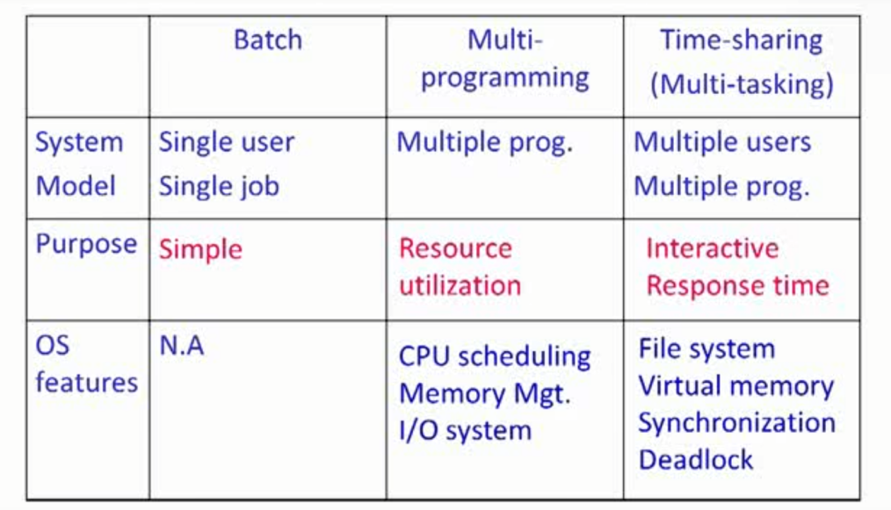

**計算機系統架構**

Computer-system architecture

- Desktop Systems: single processor

- Parallel Systems: tightly coupled

- Distributed Systems: loosely coupled

**Desktop Systems: Personal Computers**

PC - computer system dedicated to a single user

User convenience and responsiveness - GUI

I/O devices - keyboards.mice,screen,printer..

Several different types of operating systems (windows,MacOS,Linux)

缺點：容易入侵，Lack of file and OS protection from users。

（沒有想到internet的概念，會有外來者的入侵，缺乏相應的security，設計不完善）

一個電腦一個使用者的概念

**Parallel System:Multiprocessor / tightly coupled system**

如果多個CPU緊密地結合在一起被稱作Multiprocessor

More than one CPU/core in close communication

Usually communicate through share memory

衍生的問題：Throughput,Economical,Reliabiliy

又分爲Symmetiric multiprocessor system(SMP), Asymmetric multiprocessor system(AMP)

SMP -每一個CPU扮演的角色相同，都可以用作計算,可以讓大家平分，使用率增加

-Each processor runs the same OS

- 缺點：因爲要去運行不用processor上面的程式，所以需要lacking的機制。所以CPU的數量不會太多，因爲沒有人管理

-require extensive synchronization to protect data integrity

-Most popular multiple-processor architecture

AMP -每一個CPU執行不同的任務

-會有分爲Master CPU & Multiple slave CPUs （所以CPU的數量可以更多）

-但是Master CPU就會被大量浪費掉，因爲沒有compute功能。

-Most common in extremely large systems

Multi-Core Processor

黨一個CPU有好幾個core，不需要通過bus來鏈接,更有效率，快

- A CPU with multiple cores on the same die(chip)

chip會有自己的cache在chip上面，可以加速存儲，把常用的資料從memory轉移到cache上

Many-Core Processor（NEW）

- GPU

Core數量(>100)

使用GPU來做計算,原本GPU只是拿來做顯示功能，發現有些一般的計算很適合，像是做圖形計算，就想到使用GPU來計算，可以更快。有犧牲掉一些東西,雖然有>100個processor但是只能同時完成一個instruction,但是可以apply 這些instruction到不同的data(Multicore data)，exp: 做Matrix,array。但是像是if else for這些就不能同時間做，需要等待。

Multiprocessor（多個CPU，有多個插槽）

MultiCore（一個CPU有多個核心）

ManyCore（有>100core在一張卡片上，可以插在CPU上來做運算）

從Memory視角去看電腦系統

**Memory Access Architecture**

系統有多個CPU，要怎麽樣讓CPU share memory

- Uniform Memory Access(UMA):

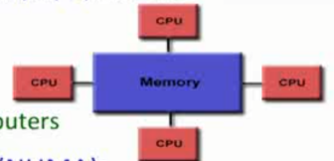所有CPU都以同個方式接到Memory上

Most commonly represented today by Symmetric Multiprocessor(SMP) machines

Identical processors

Equal access times to memory (access times是相同的)

程式執行的時候不用擔心執行在哪個memory，因爲都是同個效能

（黨我的CPU變多，需要更多的計算核心，CPU就需要去互相搶核心來使用,效能就會變慢）

- Non-Uniform Memory Access(NUMA):

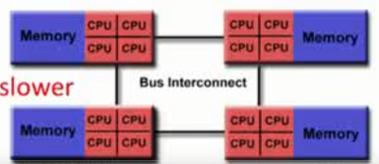會把CPU分區域，然後每個區域的共用不同的memory，然後區域和區域之間再使用bus去來連接。CPU使用同一區域的MEMORY一定比較快。

Often made by physically linking two or more SMPs（把>1的UMA接在一起）

One SMP can directly access memory of another SMP

Memory access across link is slower

**Distributed Systems :**

- Also known as loosely coupled system

Each processor has its own local memory

Processors communicate with one another through various communication line(I/O bus or etwork)

Easy to scale to large number of nodes(hundreds of thousands , e.g. Internet)

透過網路，網路綫連接在一起

- purposes

Resource sharing

Load sharing（可以平分工作量）

Reliability（比較容易做到，因爲一臺電腦crash掉不會影響到別的電腦）不會出現黨其中一個program crash掉后，system就不能運作

- Architecture: peer-to-peer OR client-server

**Distributed Systems :Client-Server**

Easier to manage and control resources

（容易架設，透過server控制讓client知道需要做什麽）

缺點：server容易成爲bottleneck and single failure point (解決方案是可以架設多臺server)

**Distributed Systems :Peer-to-Peer**

沒有區分server client ，大家同等

Every machine is identical in its role in the distributed system - decentralized

不會出現bottleneck的問題

Example:ppStream , bitTorrent , Internet (球賽直播)

**Clustered Systems**（屬於分散式系統，但是是特殊case）

Cluster computers share storage and are closely linked via a local area network (LAN) or a faster interconnect,such as InfiniBand (up to 300 Gb/s). （在自己區域内，通過LAN或網路綫鏈接）

Asymmetric clustering: one server runs the application while other servers standby

Symmetric clustering: two or more hosts are runnning application and are monitoring each other

**Summary**

Single core -> Multi-core -> Multi processor -> Cluster -> Distributed

**Special-purpose Systems**

-Real-Time Systems

Keeping deadlines,每個工作都有一個deadline,在deadline之前做完，使用者定一個可以接受的response time

Well-defined fixed-time constraints

Guaranteed response and reaction times

Often used as a control device in a dedicated application:（汽車系統，有需要時間觀念的）

>Scientific experiments,medical imaging systems,industrial control systems,weapon sys

Real-time requirement:hard or soft

Soft real-time requirements:

>Missing the deadline is unwanted（盡量完成）,but is not immdediately critical

>A critical real-time task gets priority over other tasks,and retains that priority until it completes

>Exp:multimedia streaming

Hard real-time requirements:

>Missing the deadline results in a fundamental failure（導致系統crash掉）

>Secandary storage limited or absent,data stored in short term memory,or read-only memory(ROM) （沒有harddrive,全部都放在memory）

>Exp: nuclear power plant controller

Multimedia Systems(不重講)

A wide range of applications including audio and video files

Issues:

- Timing constraints : 24 ~ 30 frames per second

- On-demand/live streaming : media file is only played but not stored

- Compression : due to the size and rate of multimedia systems

Handheld/Embedded Systems

Personal Digital Assistants(PDAs)

Cellular telephones

HW specialized OS

Issues

Limited memory (memory會比較小)

Slow processors (處理器慢)

Battery comsumption (電池消耗)

Small display screens (小屏幕)

可以以不同角度來看待整個computer system,每個system都有自己擅長的領域

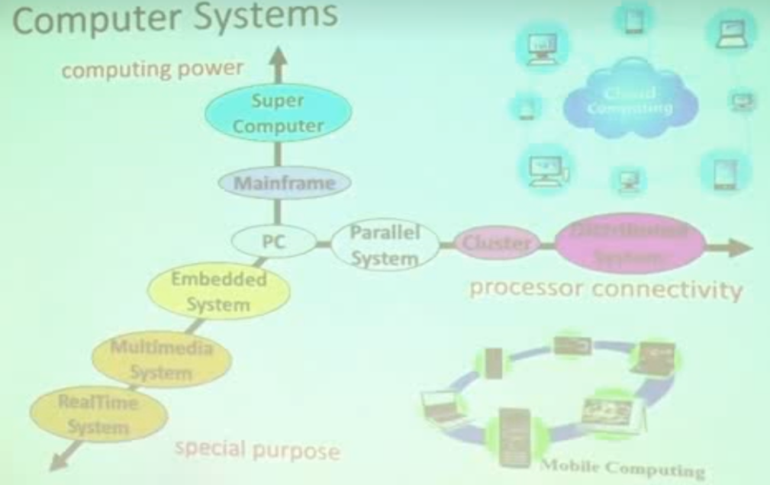

What is an Operating System?

Computer-System Organization 一個基本的電腦系統架構和OS怎麽管管理

HW Protection 怎麽去保護一個電腦,不要讓一個project的crash掉去影響整個system

**What is an Operating System?**

Computer System Structure

1.Hardware — provides basc computing resources(CPU,memory,I/O devices)

2.Operating System — control and coordinates the use of the hardware/resource

(控制和協調Hardware 在Applications 和 Users 之間的使用)

3.Applications — define the ways in which the system resources are used to solve the computing problems

4.Users — people,machines,other computers

多個User 使用不同的Application , Operating System 分配 Hardware 提供 不同 Application 所需要的computing resource

An operating system is the “permanent” software that controls/abstracts hardware resources for user applications.

只要一開機 OS就會啓動直到關機。把hardware抽象化，把一堆physical machine 變成類似virtual machine 的API 讓使用者去call來使用。

- Manages resources and processes to supprt different user applications

- Provides Applications Programming Interface(API) for user applications

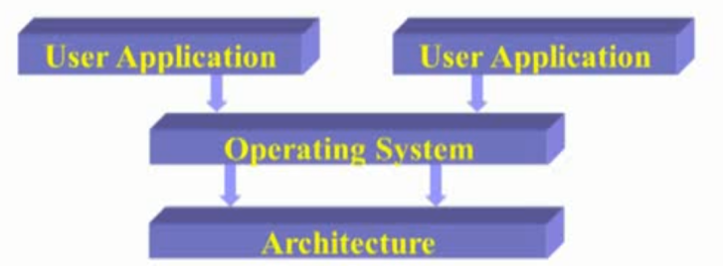

因爲OS只有一個，上面有多個不同的用戶，這樣OS就可以決定/分配哪個user需要哪些資源.電腦上面的程式一定都是透過OS來執行

例子：

OS提供一堆的API （System library）system call 。 放在OS interface等著user使用。

User先compiler了程式后，再linker程式，會簡介自動link system library，之後就會產生執行檔。

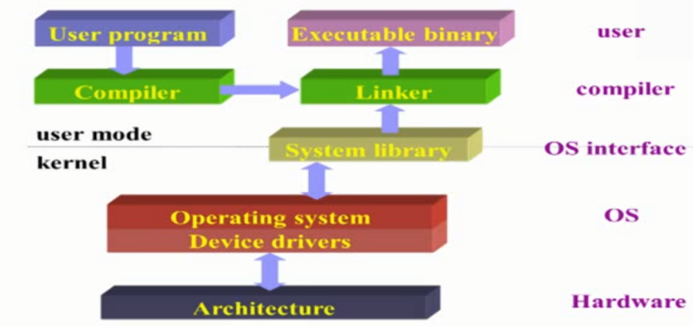

Definition of an OS

》Resource Allocator — manages and allocates resources to insure efficiency and fairness

》Control program — controls the execution of user programs and operations of I/O devices to prevent errors and improper use of computer （有drive可以讓我去控制hardware）

》Kernel — the one program running at all times (all else being system/application programs)

OS的別名

Goals of OS

- Convenience 方便

> make computer system easy to use and compute

> In particular for small PC

- Efficiency 效率

> use computer hardware in an efficient manner

> Especially for large,shared,multiUser systems

Two goals are sometimes contradictory矛盾

In the past,efficiency is more important

》System API are the only interface between user applications and harware

是硬體與軟體之間唯一的一個interface

- API are designed for general-purpose,not performance driven

》OS code cannot allow any bug 不能有一點bug，因爲如果一crash掉，整個系統都會crash

- Any break(e.g. invalid access) causes reboot

》The owner of OS technology contorls the software & hardware industry

OS掌握了上面software的開發和下面hardware的開發。因爲software想要run在OS上，就要follow rules of OS

》Operating systems and computer architecture influence影響 each other

OS也要配合著用戶不斷調整，因此會有不同的OS面對不同的devices

Modern OS

- x86 platform : Linux,Windows

- PowerPC platform : MacOS

- Smartphone Mobile OS : Windows10 Mobiles,Android,IOS,...

- Embedded OS : Embedded Linux,Windews CE,Xbox,Raspberry Pi,...

**SUMMARY**

define of OS？

Goals of OS?

Importance of OS?

**Computer-System Organization**

One or more CPUs,devices controllers connect through common bus providing access to shared memory

**Goal:** Concurrent并行 execution of CPUs and devices competing for memory cycles

Each device controller is in charge of particula device type

Each device controller has a local buffer

（因爲CPU很快，不可能一直持續地在input，所以先寫完寫到buffer，再一次過送到CPU,由controller來執行）但是buffer是有限的，必須要等buffer清空才能繼續搬data

I/O is from the device to controller’s local buffer

CPU moves data from/to memory to/from local buffers in device controllers

但是後半段的BUS是CPU在使用的，所以後半段的BUS,I/O,一定要CPU下指令來完成

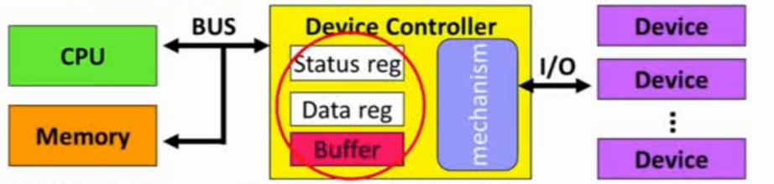

Busy/wait output 程式

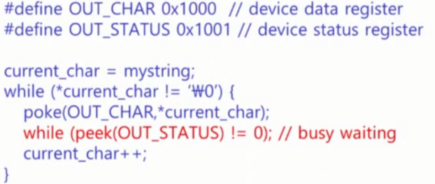

如果電腦系統架構需要一直去主動監控的話，就無法分割CPU和I/O去運作

**Interrupt I/O**

Busy/wait is very inefficient如果CPU需要一直去主動監控的話，就無法分割CPU和I/O去運作  
 - CPU can’t do other work while testing device

- Hard to do simultaneous I/O

Interrupts allow a device to change the flow of control in the CPU

- Causes subroutine call to handle device

Interrupt I/O Timeline

我們只需要在I/O transfer done后，使用Interrupt切換OS , 讓CPU過來處理一下結束后又return continue work

CPU下指令給Controller,讓Controller進行jobA搬指令的動作，結束了才發一個interrupt去找CPU.通知data已經搬進了memory，讓jobA已經可以是CPU直接去exec的狀態。A的Interrupt handler就會打斷目前CPU進行中的jobB,先去查看，然後去執行A的Interrupt handler，讓job A的狀態成爲初始化的狀態。然後再回來jobB繼續做。

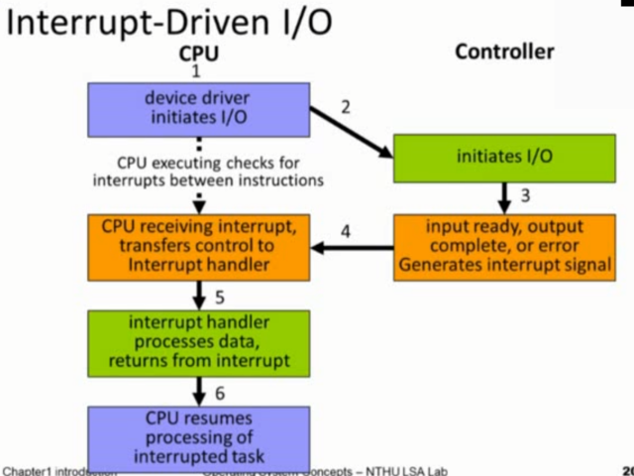

**Interrupt**

Modern OS are interrupt driven 目前所有的系統都是Interrupt driven

The occurrence of an event is signaled by an interrupt from either hardware or software.

> Hardware may trigger an interrupt at any time by sending a signal to CPU.

硬體的interrupt叫signal

> Software may trigger an interrupt either by an error (division by zero ) , or by a user request for an OS services(system call)

程式的interrupt產生的情況: error 原本的program無法繼續執行,或者呼叫system call的時候。System call的執行方式都是間接透過interrupt

> Software interrupt also called trap

軟體的interrupt 叫 trap

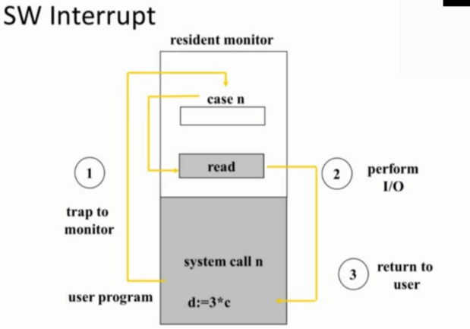

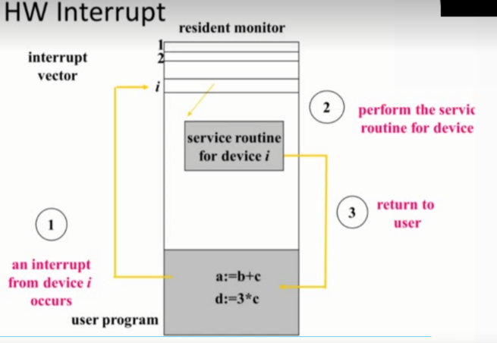

Interrupt vector (HW) , switch case (SW)

Common Functions of Interrupt

- Interrupt transfer control to ther interrupt service routine generally,throught the interrupt vector,which contains the addr(function pointer) of all the service routine (之後才可以回到原本的地方繼續exec)

- Interrupt architecture must save the addr of the interrupted instruction

- Incoming Interrupts are disables while another interrupt is being processed to prevent a lost interrupt

在執行中斷期間 又被中斷的話 就會產生需要一直去記錄每一個interrupt的狀況。所以是不允許的,後面來的interrupt就會被disabled，這是爲了保證我的service routine能正常運作并且跑得很快。

**Summary**

What is interrupt and how does it work?

What is the difference between trap and interrupt(signal)?

**Storage-Device Hierarchy**

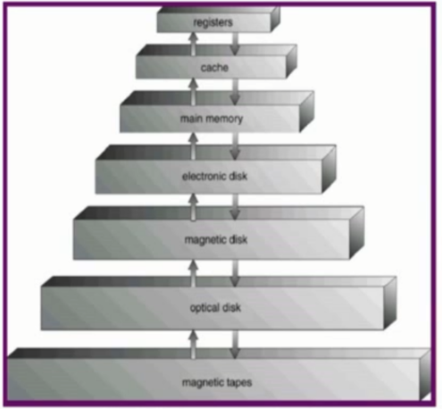

越上面越快，容量越小。

電腦系統根據Hierarchy架構來設計，是最有性價比的。

Main memory往下，統稱為Secondary Storage。

Storage systems organized in hierarchy

> speed, Cost, Volatility（關掉就資料遺失）

分割點: Main Memory - only large storage media that the CPU can access directly

> RAM : Random Access Memory

Secondary Storage - extension of main memory that provides large nonvolatile storage capacity

> Magneric disk

Random Access：讀取任何位置的資料，所花的時間都一樣

Disk Mechanism

- Speed of magnetic disk

Transfer time = data size/transfer rate

不同位置的資料的讀取時間不一樣，沒有絕對位置，只是剛好要找到的資料如果轉到附近，那麽讀取速度就快，如果在對面，就要轉過去，速度就會慢,因此時間不統一，因此disk的速度要看轉動的快慢。

Positioning time(random access time)

- seek time(cylinder) + rotational latency(sector)

**Caching**

- Information in use copied from slower to faster storage temporarily

資料既然讀了，就會把它從disk抓取到上層，如果復讀性高的話就會copied到更上層

- Faster storage (cache) checked first to determine if information is there

> if it is,information used directly from the cache(fast)

> if not,data copied to cach and used there

資料都是copied到上層而不是移動，所以disk裏面永遠都留存一份。

第一次使用的data都會比較慢，然後因爲Hierarchy的機制，會copied到上層以防下次使用。

黨我要讀取大量資料的時候，但是速度也會變慢，因爲抓data的時候會一層一層往下檢查，然後再一層一層copy上來，因此處理巨量資料的系統都不適用cache

Coherency and Consistency一致性 Issue

- The same data may appear in different levels

Issue: change the copy in register make it inconsistent with other copies

黨修改資料的時候，改了cache的但是還沒upload到memory會導致和其他copies出現不一致性

Single task accessing:

- No problem,always use the Highest level copy

電腦系統是沒問題的，只要保證大家最高L1 cache的資料是一致的，那麽電腦暫時正常運作是ok的，所以要保證使用者看到的資料是一致的就可以了。

Multi-task accessing:

- Need to obtain the most recend value

因爲不同的Client的cache不相同，然後假如memory裏面的内容與我的cache不一樣，那麽別的Client取得的資料也會與我不一樣

Distributed system:

- Difficult b.c. copies are on different computer

因爲網路會斷綫，要怎麽保證斷綫了也可以保存資料？

**Hardware Protection**

Dual-Mode Operation

I/O Protection

Memory Protection

CPU Protection

**Dual-Mode Operation**

What to protect?

- Sharing system resources require OS to ensure that an incorrect program cannot cause other programs to execute incorrectly 爲了保證程式的正確性，指令都可以運行在正確的程式裏

- Provide hardware support to differentiate between at least two modes of operations

1. User mode - execution done on behalf of a user
2. Monitor mode (kernel mode / system mode) - execution done on behalf of operating system

要區分開來哪一些是user mode,哪一些是kernel mode 。不然隨便一個user都可以任意透過OS來實現任何的動作，這樣system就會出現混亂。

- Mode bit added to computer hardware to indicate the current mode:kernel(0) or user(1)

- When an interrupt/trap or fault occurs,harware switches to monitor mode

黨有interrupt發生，就會切換mode去kernel mode。然後在kernel mode内可以通過指令再切換會user mode. 但是user mode不能發出切換到kernel mode的指令。

- Privileged instructions特權指令

只能運行在kernel mode,如果被usermode call ，就會發出一個interrupt給kernel mode

Executed only in monitor mode

Requested by users(system call) 或透過system call，是kernel已經寫好的函數讓user使用,user request system call 時，就會透過kernel，在kernel的控制下來完成該動作

**I/O Protection**

All I/O instruction are privileged instuctions

- Any I/O device is share between users

Must ensure that a user program could never gain conrol of the computer in monitor mode

**Memory Protection**

Protect

- Interrupt vector and the interrupt service routines 要保護的兩個值

- Data access and over-write from other programs （被入侵的方式）

HW suppport : two registers for legal address determinations:

- Base register — holds the smallest legal physical memory address

- Limit register — contains the size of the range

讀和修改memory都需要符合這兩個條件，（邏輯上它是個連續空間，然後Base register會記錄起始位置，和Limit register會記錄它有多長。然後來判斷你的有效範圍在哪裏。黨你指到超出範圍的memory 就會顯示錯誤。）

Memory outside the defined range is protected

黨我要修改base ,limit register這兩個值，這個指令一定是 privileged instuctions。

**CPU Protection**

Prevent user program from not returning control

避免一隻程式霸占我的CPU，然後不交還其控制權

- getting stuck in an infinite loop

- not calling system services

HW support : Timer — interrupt computer after specified period

時間到了就會丟一個interrupt出來，然後叫OS出來，切換程式執行

- Timer is decremented every clock tick

- When timer reaches the value 0. an interrupt occurs

Timer commonly used to implement time sharing

Load-timer is a privileged instruction只有OS可以調整我的Timer，user不可以

Summary

Dual-mode Operation?

CPU protection?

Memory Protection?

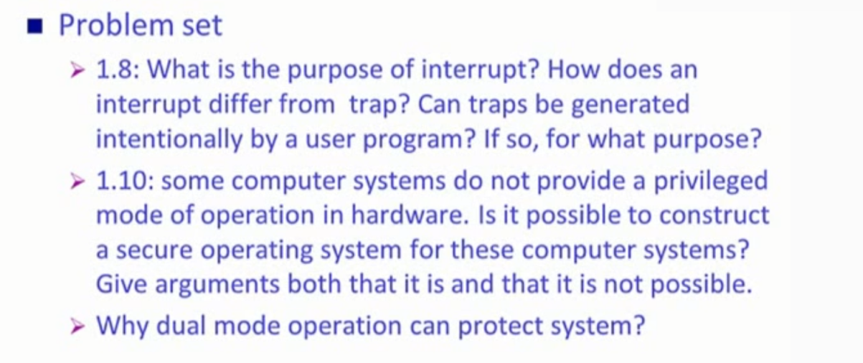

**Chap2 OS Structure**

OS Services 介紹有哪些類型的services

OS-Application Interface 介紹什麽是API 什麽是system call 區分開

OS Structure (介紹還有哪些類型，virtual Machine是其中一種)

OS Services

- User Interface

- Program Execution

- I/O operations

- File-system manipulation 管理File-system

- Communication (proccess之間的溝通，network的溝通，平行程式)

- Error detection （不讓error影響整個sys的運行）

- Resource allocation （含以下 ensuring the effiecient operation of the 自己的system)

-Accounting

- Protection and security

User Interface

CLI(Command Line Interface)

- Fetches a command from user and executes it

- Shell:Command-line interrpreter(CSHELL,BASH)

-Adjusted according to user behavior and preference

透過shell程式來和CLI做溝通 ，並不屬於OS的一部分。它是CLI的interface

GUI(Grapic User Interface)

- Usually mouse,keyboard,monitor

- Icons represented files,programs,actions,etc永圖標來表示

- Various mouse buttons over objects in the interface cause various actions

Most system have both CLI and GUI

**Communication Models**

根據memory的使用，可以分成兩大類message passing & shared memory

因爲CPU只對memory做溝通

Message passing : 在做process間的memory copied, 只能透過OS來做才是合法的，通常會比較慢

Shared Memory : 對一個共同可以看到的shared memory，都有權力去w/r，那麽就直接對shared memory做w/r達到溝通。但是shared memory一樣是system call提前生成好的。

（不限於同一臺電腦）,壞處是deadlock scheduling

**Applications-OS Interface (system call vs API)**

System Calls 程式去和呼叫OS 透過System call， 人去呼叫用CLI,GUI

- Request OS services

Process control

File management

Device management

Information maintenance

Communications

- The OS interface to a running program (屬於OS的一部分，最外面OS interface定義)

- An explicit request to the kernel mode via a software interrupt (才有機會切換user mode，kernel mode)

- Generally available as assembly-language instructions (用assembly寫的，才夠快)

API: Applications Program Interface （爲了方便application和使用者寫program而設計的）

- Users mostly program against API instead of system call

- Commonly implemented by language libraries, e.g.,C Library

- An API call could involve zero or multiple system call 一個API可以溝通多個systemcall來完成，

Both malloc() and free() use system call brk()

Math API functions,such as abs(),don;t need to involve system call也可以不溝systemcall來完成

在寫program的時候不會直接touch到system call,都會against API interface。最常見的API (C Library : libc ) ，然後API再去call system call. Call 了 API 不會進到kernel mode，它是call 了API ，API裏面再call 了system call 產生了一個interrupt才會簡介透過OS去完成。

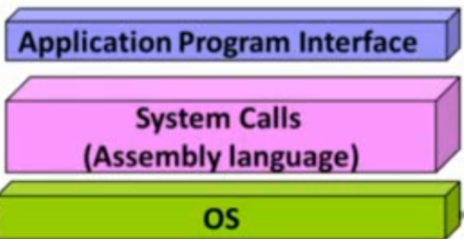

Three most common APIs : Win32 API , POSIX API , JAVA API for Java virtual machine(JVM)。

Why use API？

- Simplicity : API is designed for applications

- Portability : API is an unified defined interface

- Efficiency : Not all functions require OS services or involve kernel

使用者可以只學會API就好，不用完全瞭解OS怎麽用

**System Call : Passing Parameters**

Three general methods are used to pass parameters between a running program and the operating system

> Pass parameters in register

> Store the parameters in a table in memory , and the table address is passed as a parameter in a register 建立一個data structure，再把它的pointer傳到function call裏

> Push(Store) the parameters onto the stack by the program,and pop off the stack by operating system (每一個process都有自己的stack，可以把資料push/pop進去自己的stack裏面)

System Structure:

- Simple OS Architecture （一開始的設計沒有很完善，會有security的問腿）

- Layer OS Architrecture （把程式每一個做區隔，再從下往上排，每一個layer的component和程式都只能往下call 不能過跳躍，因此儅出現問題只要從最近的,所以黨出現問題，或修改程式的時候，你可以知道你只會影響到下面的那層，所以debug會容易很多）

- Microkernel OS （把kernel最核心的部分定義成kernel，其他部分全部定義成module,可以去對module做替換的動作，module run在user space，因此在溝通的時候必須要通過message passing。效能會比較慢嗎，但是會更reliable，因爲kernel很小，出錯的幾率小）

- Modular OS Structure（目前主要的架構，和Mircrokernel差不多，只是它吧一堆的module都放在kernel裏面，就不會出現溝通還需要通過message passing的問題。）

- Virtual Machine

- Java Virtual Machine

**User goals & System goals**

User goals — operating system should be easy to use and learn, as well as reliable ,safe,and fast

System goals — operating system should be easy to design,implement,and maintain,as well as reliable,error-free and efficient

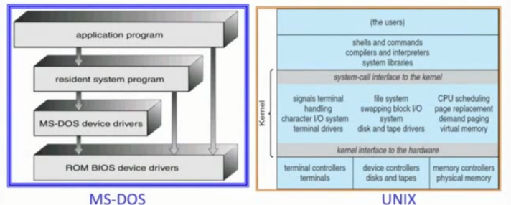使用者希望方便User使用，而系統希望方便系統容易維護和debug，然後都要reliable，因爲kernel是不可以出錯的

**Simple OS Architecture (MS-DOS)**

- Only one or two levels of code

- Drawbacks : Un-safe，difficult to enhance

**Layer OS Architrecture**

- Lower levels independent of upper levels

N^th of layer can only access services provided by 0 ~ (N-1)^th layer

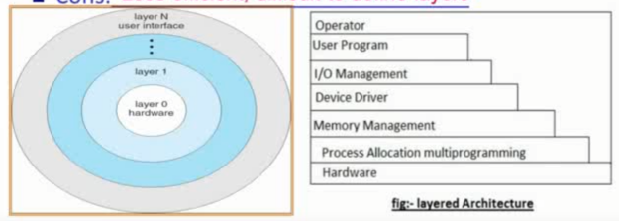Pros: Easier debugging/maintenance把全部都切成一個個layer，然後外圈可以call内圈的API system ,

Cons: Less efficient,diffiuclt to define layers

它less efficient是因爲它只可以一層層去call

Microkernel OS

- Moves as much from the kernel into “user” space

- Communication is provided by message passing

- Easier for extending and porting

我kernel的程式碼要越少越好，因爲就比較reliable，然後它把subsystem都變成一個個的module，所以kernel只要負責去溝通module之間怎麽傳輸和interface，只要在kernel外面的都是user mode 。所以那時候I/O manager那些component都是user mode。

Cons: 效能更差，每個部分溝通都要通過kernel,因爲其他component都在user mode,所以後期同步問題都會要通過message passing來做資料傳輸

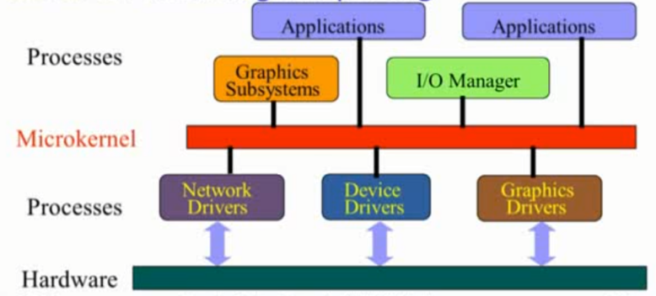

Modular OS Architecture （目前流行）

- Most modern OS implement kernel modules

Users object-oriented approach

Each core component is separate

Each talks to the others over known interfaces

Each is loadable as needed within the kernel

- Similar to layers but with more flexible

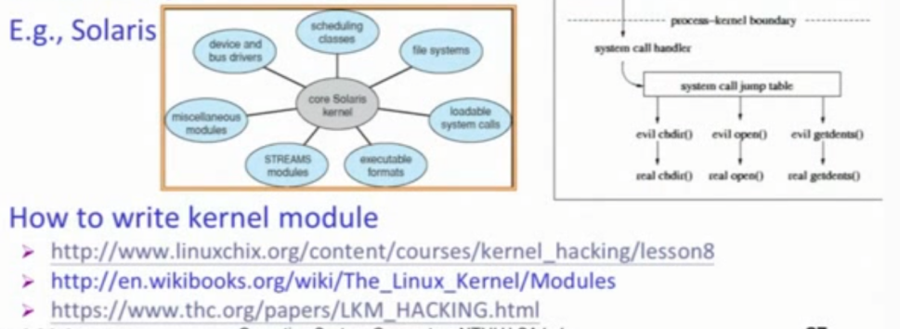

用物件導向的概念，把每個component都變成一堆subsystem，然後每個subsystem都要定義好自己的interfaces,利用interfaces來做溝通。另外全部都在kernel内，所以溝通不需要透過message passing。

**Virtual Machine**

Takes the layered approach to its logical conclusion

It treats hardware and the OS kernel as thrugh they were all hardware

Provides an interface indentical to the underlying bare hardware

Each process is provided with a (virtual) copy of the underlying computer

Difficult to achieve due to “critical instruction”

它把下面的作業系統,hardware和軟體抽象化，

雖然有了OS，但是還可以再灌多另一個OS

所以VM的作用其實就是讓我上面的kernel誤以爲現在system只有他一個kernel，而hardware獨屬於它的。然後每一個kernel都這樣認爲，但是事實上這臺system共有三個不同的kernel正在運作。

所以對於系統而言。上面的kernel其實是run在user space裏面的kernel。

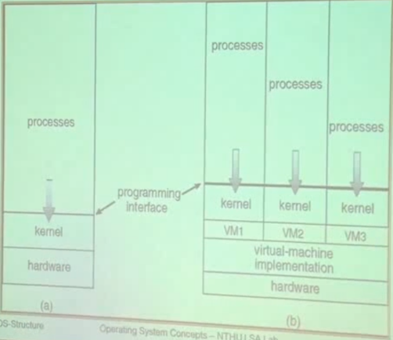

在我上面的kernel如果call了一個privileged instruction的時候，因爲它其實是在user space call 所以它事實上會被擋下來。但是他這時候就會發出一個interrupt到我們sys真正的kernel space.然後在裏面它會看到原來是VM的kernel call的，那它就會在真正的kernel space再幫它call多一次。所以最后就可以call成功。

(它攔截了interrupt后再幫它call一次)所以VM效能差，因爲會比別人多做一次

Usage of VM

- provides complete protection of system resources

- a means to solve system compatibility相容性 problems

因爲黨我只有windows后MacOS系統的時候，有另一份jobu需要靠別的kernel來實作，那麽我其實只要在我這臺system上灌一個Vm在裏面在下載就可以實做了

- a perfect vehicle for operating-systems research and development

因爲黨我在我的電腦做research的話，黨出現bug就會導致我整個system crash掉，然後上面的資料全部都Loss掉了，長時間下來就會導致我電腦提早壞掉，所以在Vm内做就不會有這個問題，因爲crash掉的也只是我的VM而已。

- A mean to increase resources utilization in cloud computing

雲端計算，

Vmware（Full Virtualzation）

- run in user mode as an application on top of OS

**Chap 3 Processes Concept**

Process Concept

Process Scheduling 講基本架構，CPU/JOB Scheduling

Operations on Processes 在processes上面可以做什麽(create)

Interporocess Communication (message passing之類的communication的其他方式)

**Process Concept**

An operating system concurrently executes a variety of programs

> Program — passive entity : binary stored in disk

> Process — active entity : a program in execution in memory

A process includes:一個process有一個它的memory space,因爲process就是在memory裏面

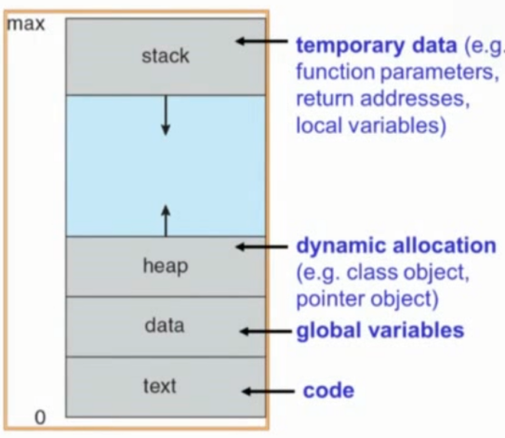 > Code segment(text section)程式碼

在程式碼裏面定義的variables會存放在三個不同的地方

> Data section — global variables

> Stack — temporary local variables and functions

> Heap — dynamic allocated variables or classes

> Curretnt activity(program counter,register contents) 存放狀態

> A set of associated resource

**Process State**

Process整個執行的過程的5個states

States:

> New: the process is being created

（要把program load到memory裏面，然後把process内的東西都create出來，再初始化全部state）

>Ready:the process is in the memory waiting to be assigned to a processor

（在要去CPU使用之前，會被放到一個ready的state,放到一個queue裏面，等待OS去排程進去CPU使用，做scheduling的動作）

>Running:instructions are being executed by CPU

（在被選中后，開始送instruction去執行的時候，的狀態）

>Waiting:the process is waiting for events to occur

（一個program在被使用的時候，CPU要去做I/O的時候，program就會被interrupt下來waiting CPU把I/O處理完，這時候就會放在waiting，然後黨CPU處理完后，這個process就會又被放到ready狀態内，等待使用）

>terminated:the process has finished execution

（New的反過來，把所有資源release掉）

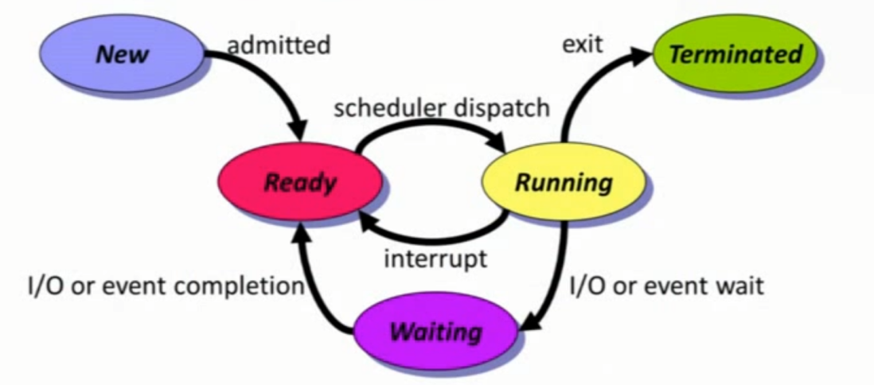

Only one process is running on any processor at any instant

However,many processses may be ready or waiting

在OS的世界裏，要能夠掌握整個整個流程來管理process。

實現的方式是讓每個process create一個的Process Control Block(PCB)，在memory記錄各種information

黨一個process被create的時候,OS OS自己就會幫它去allocate一個table叫PCB，去幫它管理。

所以黨我們講把process放到一個queue，裏面，事實上是把PCB放到queue裏讓CPU來使用.然後用linkedlist來串在一起。

Info.associated with each process

- Process state 在什麽狀態

- Program counter program執行的位置

- CPU registers

- CPU scheduling , Memory-management , I/O status , Accounting information

Context Switch

要把原本在CPU上執行的process 把它switch成另一個process

發生的契機，一定是因爲interrupt 或有人呼叫system call,才會切換到其他的program。然後把所有的CPU state全部存到PCB0,然後再把所有的state也load一遍到新的process的PCB1裏面。在save/reload state(做 context switch)的動作時候，兩個process也是idle的狀態。只有結束Context Switch后，才會開始executing。

>kernel saves the state of old process and loafs the saved state for the new process

也叫做overhead（Overhead - 只要computer system沒有在run user’s program的時候就叫Overhead）

所以我們希望Context Switch的動作越快越好，但是無法避免Context Switch。、

Switch time depends on

- memory speeds

- number of register （減少數量，那麽就減少存儲的數量）

- exinstence of speial instructions

（把load/save和中間幾個intructions合并成一個intruction.這樣只要call一次就好，省掉好幾個動作）

- hardware support

Multiple sets of registers（原本只要一個register就好，但是使用多個register來記4到5個program起來，然後在做Context switch的時候，只是把一個register位置，搬到另一個register位置裏面）

Summary

What’s the definition of a process?

What’s the difference between process and thread?

What’s PCB? Its contents? （Process state,Program counter CPU registers）

The kinds of process state?

What’s context Switch?

**Process Scheduling**

因爲process都會被存放在memory裏面，然後在ready的狀態下等待CPU的使用，所已scheduling管理著processes之間誰前誰后

Multiprogramming: CPU runs process at all times to maximize CPU utilization

Time sharing: switch CPU frequently such that users can interact with each program while it is running

Processes will have to wait until the CPU is free and can be re-scheduled

**Process Scheduling Queues**

process會進到一個queue中去進行等到被load

Job Queue (New State) — set of all processes in the system

（決定誰，哪個program有這個狀態可以load到我的New State）決定什麽時候可以有一個program load到memory成爲一個process

Ready Queue(Ready State) — set of all processes residing in main memory,ready and waiting to execute

Device Queue(Wait State) — set of processes waiting for an I/O device

I/O的waiting queue，我們會有很多個不同的device 的queue,每一個device都會有自己的queue

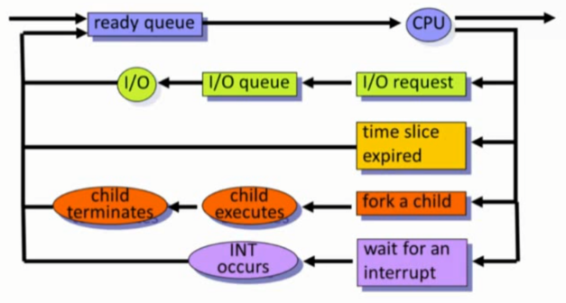

Schedulers

因爲CPU數量少，但是在memory裏面的要執行的program是非常多的，而且準備，希望被Load到memory的job又是更多。

在CPU裏面是running State,耳仔Memory裏面就是ready State,還在disk裏面的是new State，只是剛被create出來的狀態

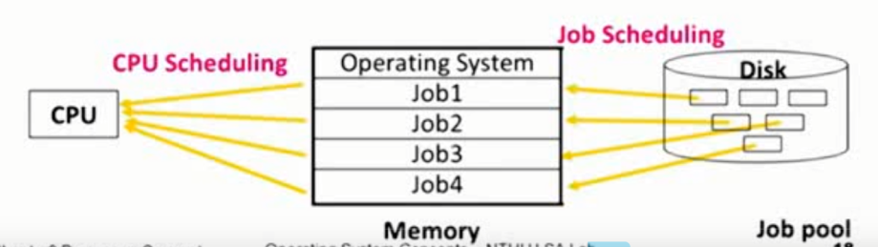

Short-term scheduler（CPU scheduler）—selects which process should be executed and allocated CPU(ready State -> run State)

CPU scheduler我們也常常叫做Short-term scheduler，因爲它發生的頻率很頻繁，會一直打斷CPU，呼叫CPU Scheduling來重新派排程

Long-term scheduler （job scheduler）—selects which processes should be loaded into memory and brought into ready queue(New State ->Ready State)

Job Scheduler也叫Long-term scheduler ,因爲時間很久，可能幾秒，幾分鐘才會做一次。因爲這邊是使用者需要去一個lauch一個process進到memory 才會產生這個動作。

Medium-term scheduler—selects which processes should be swapped in/out memory(ready State -> wait State)

差別是:什麽時候會把一個process swapping回去Disk裏面。(和vector memory有關係)

因爲memory不夠空間了，所以會需要挑出一些process出來，以memory content的形式放回去Disk裏面，然後之後被選中才回到ready State才開始執行

(不活躍或暫時不需要的進程從主記憶體換出到磁碟)

**Long-term Scheduler**

- Control degree of multiprogramming(這臺電腦上有多少個process在memory裏面)

Degree不可以太高，因爲太多process一直在爭搶，然後電腦就只會一直做swapping

- Execute less frequently（invoked only when a process leaves the system或幾分鐘一次）

- Select a good mix of CPU-bound & I/O-bound processes to increase system overall performance

要去考慮要怎麽選擇哪些process，可以重叠我CPU & I/O的時間。

因爲假設我load進來的process全部都是做I/O，那麽我做I/O的時間就會很多，導致CPU always idle. 希望我CPU的時間和I/O的時間可以overhead

**Short-term Scheduler**

- Execute quuite frequently（once per 100ms）非常快

- Must be effiecient:

If 10ms for picking a job, 100ms for such a pick, overhead = 10/100 = 9%

演算法：很多人在ready queue裏面，所以我們定義效能的方式是用大家的average waiting time。 所以在同一個情景下，不同的演算法可以得到不同的average time.所以設計不同演算法可以導致我的效能好不好。

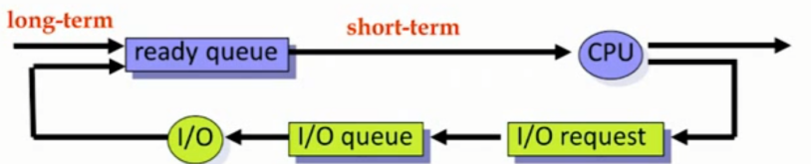

**Medium-term Scheduler**

Swap out: removing processes from memory to reduce the degree of multiprogramming

把process從memory搬回去disk裏面，（控制degree of multiprogramming）

Swap in: reintroducing swap-out processes into memory

讓等在disk的人可以再回到memory上面再做一個執行的動作

Purpose: improve process mix, free up memory

它可以全部load 到memory，然後再去挑選哪些process可以run在memory上面，平均了process用CPU &I/O的時間。 然後黨degree太高，可以通過medium-term scheduler去清理我的memory

**Operations on Processes**

Tree of Processes

Each process is identified by a unique processor identifier(pid)

process只要被create出來就是被assign一個pid,因爲一開始system都只有一個process，然後才再那個process底下create不同的process出來，所以其實可以根據這五個點畫出一個tree出來。

Process Creation（parent和children的關聯性）

- Resource sharing （可以定義三種不同resource sharing的狀態）

Parent and child processes share all resources

Child process shares subset of parent’s resources

Parent and child share no resources

- Two possibilities of execution執行順序

Parent and children execute concurrently (沒有先後順序，讓OS自己決定看誰先誰后執行)

Parent waits until children terminate (children有比較高的priority執行權)

- Two possibilities of address space

Child duplicate of parent,communication via sharing variables

Child has a program loaded into it,communication via message passing

黨我create了一個new process child，看是child在執行的程式碼和父母完全一樣，還是child是重新建構一個新的程式跑

**Process Termination**

- Terminate when the last statement is executed or exit() is called

All resources of the process ,inluding physical & virtual memory,open files,I/O buffers,are deallocated by the OS

把一開始init的資料全部再deallcated,release掉

- Parent may terminate execution of children processes by specifying its PID（abort）

Child has exceeded allocated resources (黨孩子被分派太多資源)

Task assigned to child is no longer required(或者任務已經結束了)

可以强制系統關掉這個process

- Cascading termination: （ctrl + C）

Killing(exiting) parent -> killing (exiting) all its children

某一個點被kill掉之後，下面所有的孩子process都會被一層層kill掉

Summary

What’s long-term scheduler?features?

What’s short-term scheduler?features?

What’s medium-term scheduler?features?

What’s the different between duplicate address space and load program? Their commands?

**Interprocess Communication(IPC)**

process之間的溝通

IPC：a set of methods fot the exchange of data among multiiple threads in one or more processes

Purposes:

- information sharing

- computation speedup 平行程式

- convenience

modularity 模塊化(multikernel)

Shared memory:

有一塊memory空間，都有權力對他做pointer的存儲

缺點(user synchronization) 優點(faster speed)

Use memory addr to access data

Message passing:

透過memory的copy來傳遞

No conflict: more efficinet for small data

Use send/recv message

Implemented by system call: slower speed

Sockets:

- A network connection identified by IP & port

- Exchange unstructured stream of bytes

所以每次首先都要先bind，找到對方的Port才知道要傳輸資料到哪裏

Remote Procedure Calls(RPC):

- Cause a procedure to execute in another address space

- Parameters and return values are passed by mesage

像call一個function code去溝通

Shared Memory

- 要有辦法去create一個memory space出來給process閒使用。

使用者要自己決定怎麽使用這個memory space,OS只負責create空間

- Determining the form of the data and the location

- Ensuring data are not written simultaneously by processes

如果有兩個使用者同時對memory space去做read/write，就會有同步問題。

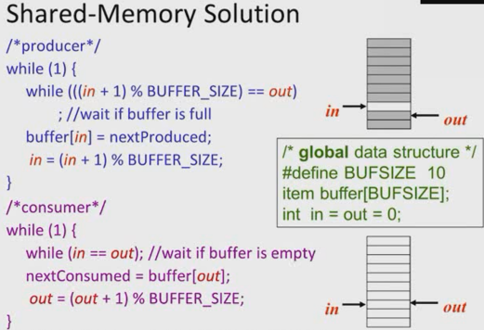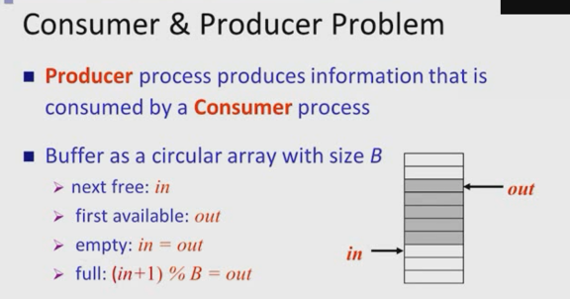

Message-Passing System

不只是包含溝通問題，還

- Mechanism for processes to communicate and synchronized thier actions

- IPC facility provides two operations:

Send(message) — message size fixed or variable

Receive

需要兩邊同時都call了這個function，才能完成這個動作

- Message system - processes communicate without resorting to shared variables

- To communicate,processes need to

Establish a communication link

Exchange a message via send/receive

Implementation of communication link

> physical（e.g.,shared memory,HW bus,or network）

> logical

Direct or indirect communication 也沒有方向性，是單一方向還是雙向

Symmetric or asymmetric communication

Blocking or non-blocking call了function，要等動作完成后return 才算做完（Blocking）

Automatic or explicit buffering

Send by copy or send by reference

Fixed-sized or variable-sized messages

Direct Communication

必須要指定我要溝通的人是誰才可以進行動作

- Processes must name each other explicitly

Send(P,message)

Receive(Q,message)

- Links are established automatically

Links不需要call別的function call再建立，它會自己建立好

- one-to-one communication

- Link may be unidirectional,but is usually bi-directional

缺點(確定好對面的process了，就不能替換了)

Limited modularity: if the name of a process is changed,all old names should be found

如果要和新的process溝通，就需要重新鏈接過。

Indirect Communication

會有一個mailboxes來接受messages (Gmail)

- Each mailbox has a unique ID

- Processes can communicate if they share a mailbox

- Send(A,message) — send a message to mailbox A

- Receive(B,message) — receive a message from mailbox A

我只是把msg放到mailbox，要的人自己去mailbox拿。所以不直接和對方做communication

- Properties of communication link

- link established only if processes share a common mailbox

因此Link要programer自己建立，因爲要自己建一個mailbox才能做溝通

- Many-to-Many relationship between links and processes

- Mailbox can be owned either by OS or processes

所以Mailbox是獨立在兩邊的，會有一個程式在負責管理msg。User只是從mailbox中copy自己需要的部分回到自己的process處理

Synchronization

> Message passing may be either blocking同步 or non-blocking非同步

- Blocking send: 除非對方真的receive到了data，那麽send端才可以return

- Blocking receive:receiver要真的拿到data才可以return

- Nonblocking send:

- Nonblocking receive:receiver今天call了一個receive,如果對面今天馬上call了一個function，那麽拿到的值就會是對的，不然拿到的值就是還未更改過的值。所以通常這個function還會包含一個token,可以在事後反檢查到底拿到的data是不是對的data.

Buffer implemention

會有一個buffer在nonblocking send/receive之間，要是sender發了一個訊息，但是對面還沒接受就存到buffer内，這樣sender就可以一直發訊息直到buffer拿，而receiver只要之後查看buffer内的内容就好了。

Sockets：

RPC(Remote Procedure Calls)

透過網路來進行message passing

- 會有一個Stubs run 在client和server端，然後由Stubs對parameter進行packet和unpacket的動作。

RPC的特色是可以跨電腦passing message。

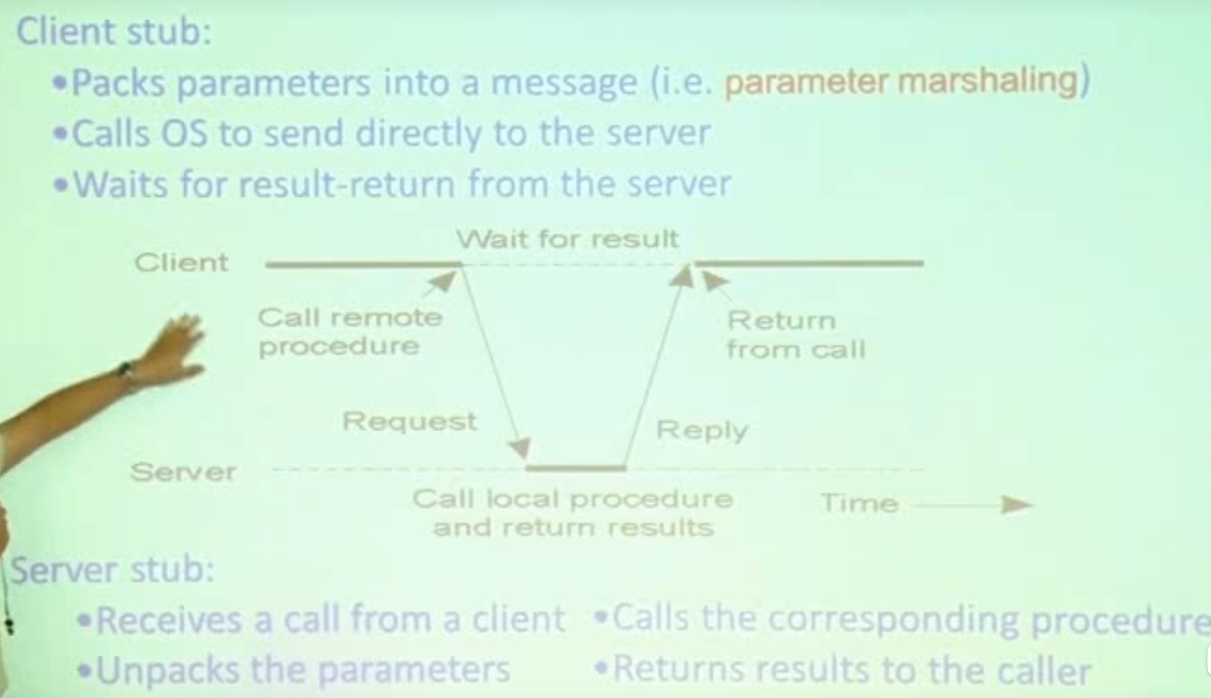

Chap 4

Thread introduction

Multithreading Models

Threaded Case Study

Threading Issues

**Threads**

lightweight process: 另外一個名字

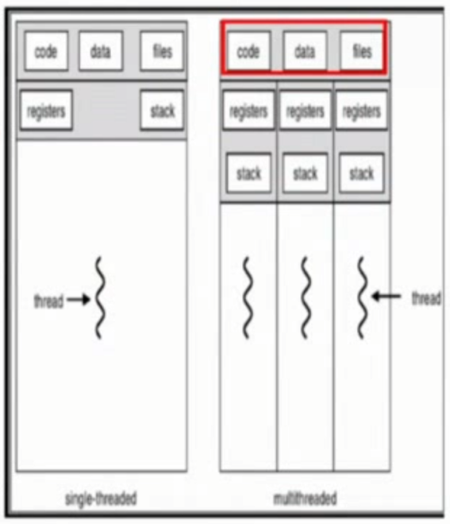和process的運作，原理，長相是完全相同的

(之前提到的share memory的溝通我們是用threads programming來完成的)

>Basic unit of CPU utilization (CPU在執行的單位其實是thread)

>因爲有些memory 在parent process那一邊已經定義好了。

All threads belonging to the same process share

>在同一個process空間下的threads，是共用部分memory space(code,data,OS resources)

>只要你有一個threads開，另一個threads立刻可以拿這個file的pointer去做read/write的動作。 但是register和stack是不共用的。

因爲每個threads在執行的位置可以不一樣執行不同的instruction,function call，所以在register内就不同，另外執行的狀態也是獨立的

>But each thread has its own（thread ID,program counter,register set ,stack) (thread control block)

stack存的是local variable

Motivation

- exp: a web browser

- exp:a web server

Benefit of Multihreading

- Responsiveness 反應，可以非常快的反應出來，不同的thread去反應不同的部分，然後每個部分都是獨立的，但是又可以互相溝通

- Resource sharing: 可以透過shared memory來做溝通，所以就可以很容易很快的得到我想要的資料

- Utilization of MP arch: 因爲目前都是multicore的電腦，因此這樣就可以很好地利用processors,然每個processors負責不同的thread

- Economy: Allocate memory and resources for process creation is costly.In Solaris,creating a process is about 30 times slower than is creating a thread, and context switching is about five times slower.A register set switch is still required,but no memory-management related work ios needed

從softwaware和hardware角度來看

- Multithreaded programming: provices a mechanism for more efficient use of multiple cores and improved concurrency

- Multicore systems: putting pressure on system designers and application programmers

OS designers: scheduling algorithms use cores to allow the parallel execution

Challenges in Multicore Programming

- Dividing activities :divide program into concurent tasks

怎麽平均地分配每個不同的core做不同的program

- Data splitting :divide data acessed and manipulated by the tasks

有時候一個data是很負責的，所以要怎麽去切分配數據

- Data dependency :synchronize data access

數據之間的dependency,有時候有些data要等別的data昨晚后才可以去運行，因爲會有不同的計算，可能第一個人要等第二個人做完了才能夠做

- Balance :evenly distribute tasks to cores

要平衡執行時間，因爲總體的時間還是跟著最慢的那個program

- Testing and debugging

因爲所有程式幾乎同時運行，然後其中又分為哪些是先做，哪些是后做，因爲先後執行順序不一樣就會造成錯誤的結果。所以要debug是一件很難的事情

**Thread的執行也是有分層的(User & kernel Threads)**

User threads - thread management done by user-level threads library不同userframe的library

- java threads

- Win32 threads

Kernel threads - supported by the kernel(OS)directly

OS裏面的基本單位

- Windows2000(NT)

- Solaris

User thread

- thread library 提供不同thread creation,scheduling

- generally fast to create and manage

在OS的上面，因爲在user threads沒有touch到system call,不需要透過interrupt和OS做溝通，所以會比較快

- If the kernel is single-threaded,a user-thread blocks ->entire process blocks even if other threads are ready to run.因爲kernel是獨立的，然後會出現many-to-one的情況，所以當我那個kernel被block著后，bind著它的user thread也被block了

-A user thread must be assigned to a kernel thread. Otherwise, it will never be executed.

Kernel threads

- kernel OS最基本去utilize CPU的program

- 因爲它在kernel裏，它會需要通過Interrupt以及system call等等不同的呼叫才能進到裏面，所以通常會比較慢

- if a thread is blocked,the kernel can schedule another thread for execution

如果有很多kernel threads，因爲每個都是獨立的，所以就算一個被block著，其他還可以正常運行。

- Many-to-one

- One-to-One

- Many-to-Many

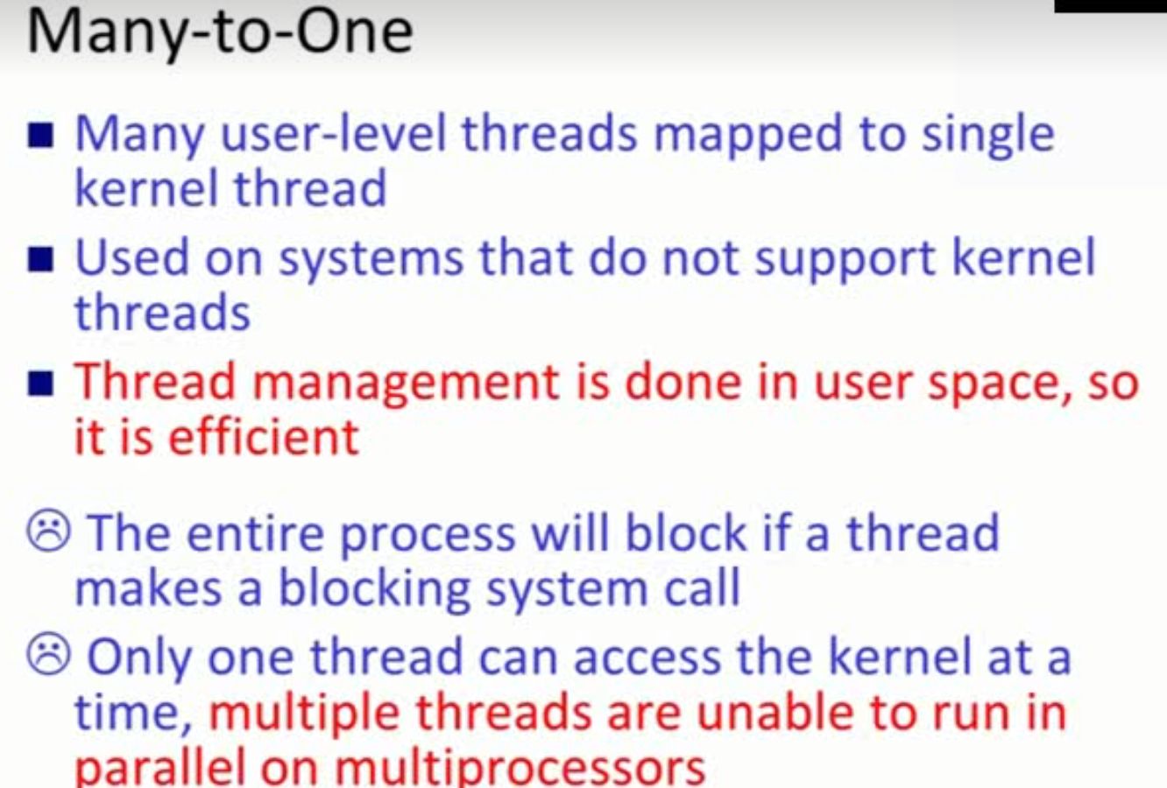 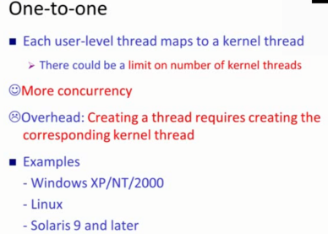 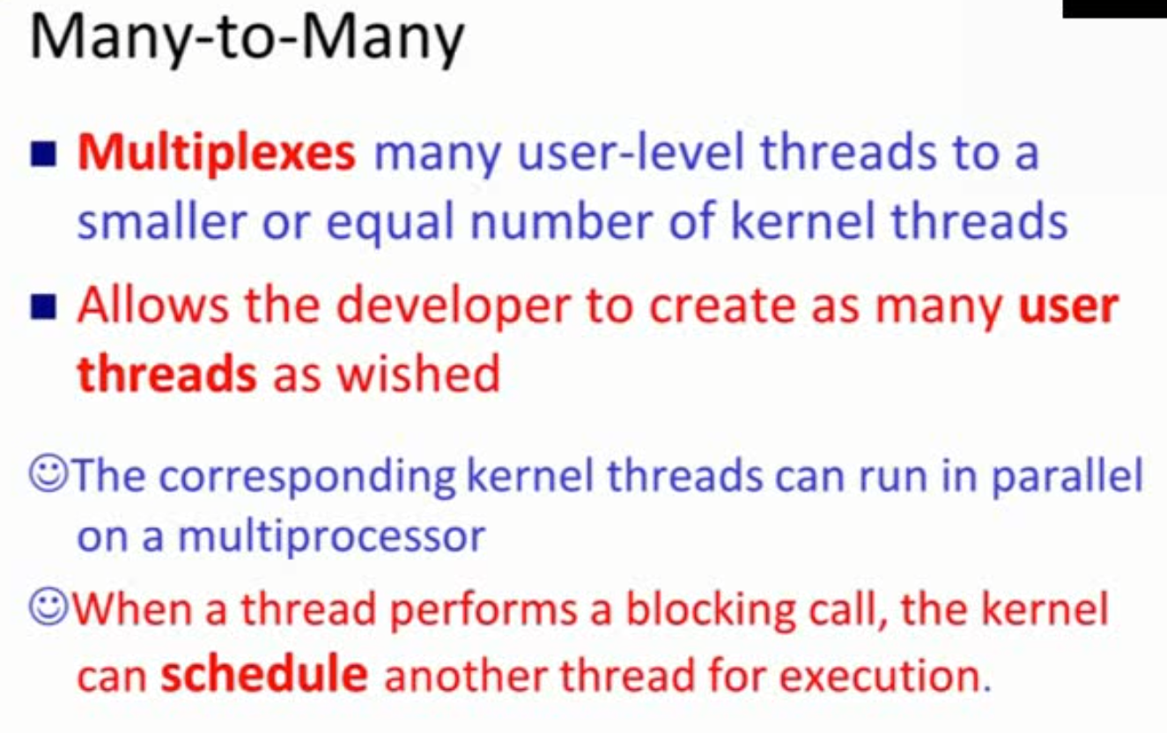

Chap5 Scheduling Algorithms

- CPU utilization

- Throughput計算電腦注重的是Throughput 系統角度

- turnaround time -(從submission算起到completion的時間) single job角度

- waiting time 一個program在waiting queue的時間，越小越好

- response time （從submission開始到第一個first response的時間）到第一個CPU field

Algorithms

不同的algorithms的好壞會看turnaround time,waiting time,response time，因爲這三個是以job為單位去

- FCFS

- SJF （根據burst time來做預測）

- Priority scheduling (low priority processes never execute)—aging,每過多久，現有的job的priority就增加

- Round-Robin scheduling 大家輪流做，然後會control每次每個的執行時間TQ可以做多久

TQ large->FIFO

TQ small ->（context switch的次數會很多）

- Multilevel queue scheduling (有不同的queue可以執行不同的algorithms，然後怎麽選擇哪個queue做，分配不同的時間time slice)

- Multilevel feedback queue scheduling (有分上下然後上下是有意義的，先做完上面的再做下面的queue。它會feedback，另外process可以在queue之間移動，會在run time的時候，觀察process的behavior，然後放到最合適的位置去執行)

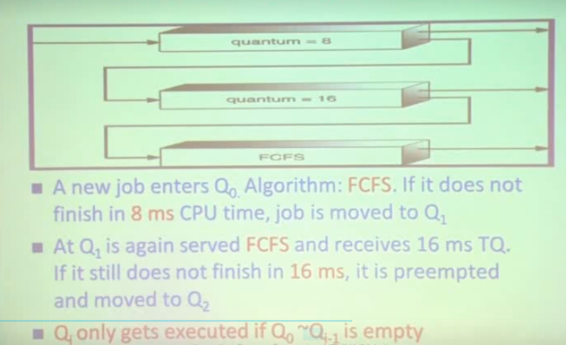 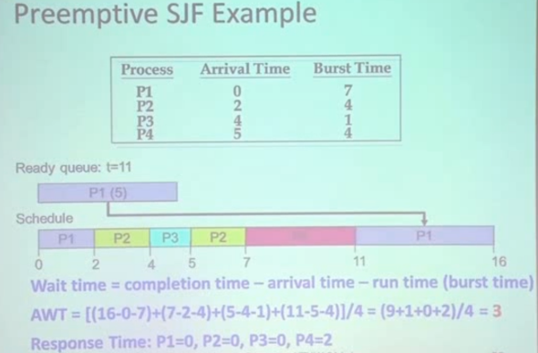

Multilevel Feedback Queue

要設計怎麽時候要往上upgrade，或往下放

Parameters:

- number of queue

- Scheduling algorithm for each queue

- Method used to determine when to upgrade a process

- Method used to determine when to demote a process

Deterministic modeling

- 你要去優化哪些不同，不同的有不同對應的algorithm （waiting time?）

去performance of each algorithm

- Queuening model - 用機率的概率去分析，有%多少的waiting time是多少，然後跟著幾率評量好壞。

- Simulation - 用模擬的方式去走一遍看看哪個演算法最好，不過一旦輸入一改變，就不一樣了,收集非常多的workload （random-number generator or trace tapes for workload generation）

- Implementation - the only completely accurate for algorithm evaluation

Summary

Preeptive scheduling vs Non-preemptive scheduling?

Issues of preempttive scheduling

Turnaroud time?waiting time?Response time？Throughput?

Scheduling algorithms

FCFS

Preeptive SJF,Nonpreemptive SJF

Priority scheduling

RR

**Rate-Monotonic (RM) algorithm**

依據頻率的大小來做排程

更短的週期(週期是固定的數值，在 run time 期間不會變動) –> 更高的優先度

同一個 task 的所有 job 都有一樣的 priority

task 的優先度是固定的

Fixed-priority RTS scheduling algorithm

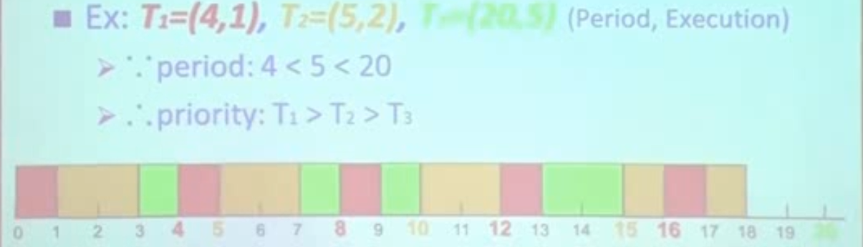

**Earliest-Deadline-First (EDF) algorithm**

更早 deadline –> 更高的優先度

動態優先的演算法

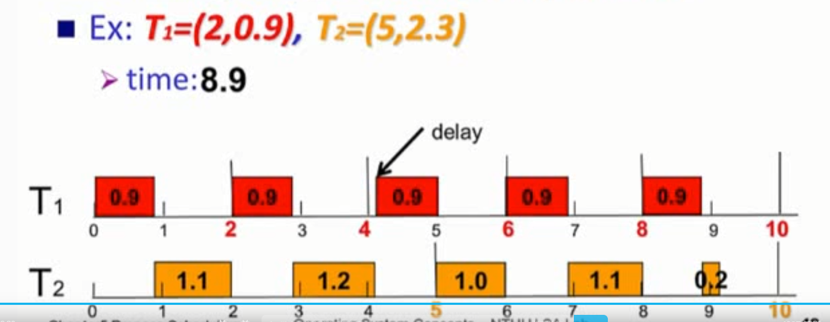

**Proportional Share Scheduling**

根據權重來分配CPU時間

T shares are allocated among all processes in the system

Application receives N shares where N < T

This ensures each application will receive N / T of the total processor time

Example, T=100 shares, the processes A, B, and C respectively need 50, 15, and 20 shares. The assignment is ok

If D that needs 30 shares, D will be denied.